EL MANDARINO
Story: Mandarino has been recruited by the rebellion to embark on a suicide mission of the highest risk, locate and rescue a small creature kidnapped by the empire of the evil Head Can. The creature is found according to our latest information in a remote imperial base called the Dying Orange, which is littered with soldiers, assassin droids and other space junk. This little creature is of vital importance to the rebel advance in their fight against the empire. Rescue him and flee as soon as possible.
Purpose of the game: Search and rescue the little creature. You will need to collect all the energy cells to activate the emergency walkway and be able to flee from the imperial base alive, save ammunition, it is scarce and you will need it in the escape ...

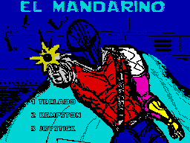

Controls: Keyboard, Kempston y Joystick
Keyboard: O – Left, P – Right, Q – Jump, Espace – Shoot
Copyguay: Mananuk ’20
Created by The Mojon Twins Churrera MK1.
Thanks To the Mojon Twins team for creating this engine and making confinement less harsh, to Mr. Patata for his ideas and testing.

